**PORTFOLIO CREATION - RESUME**

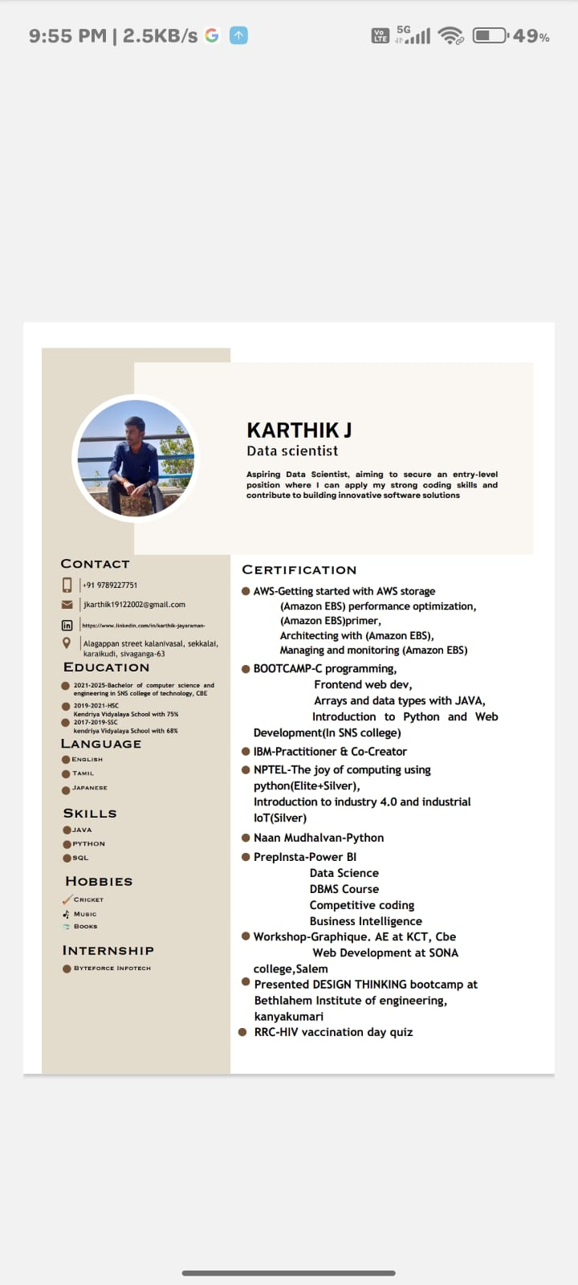

**PSYCHOMETRIC TEST & MARKS**

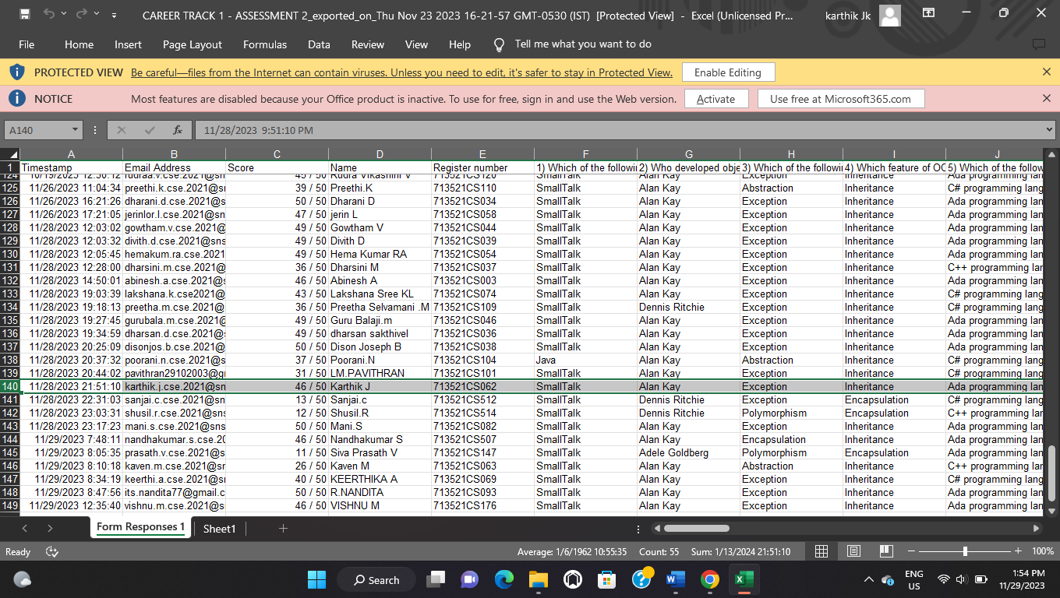

**VIDEO RESUME**

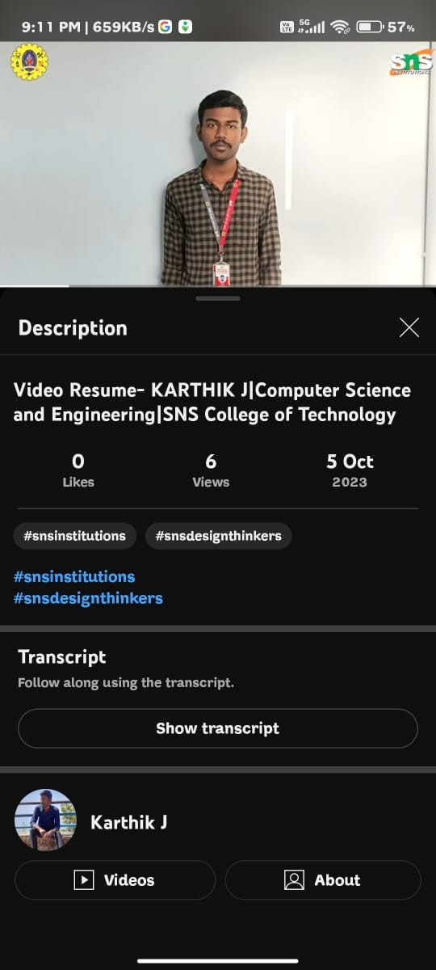

**BUSINESS CARD CREATION**

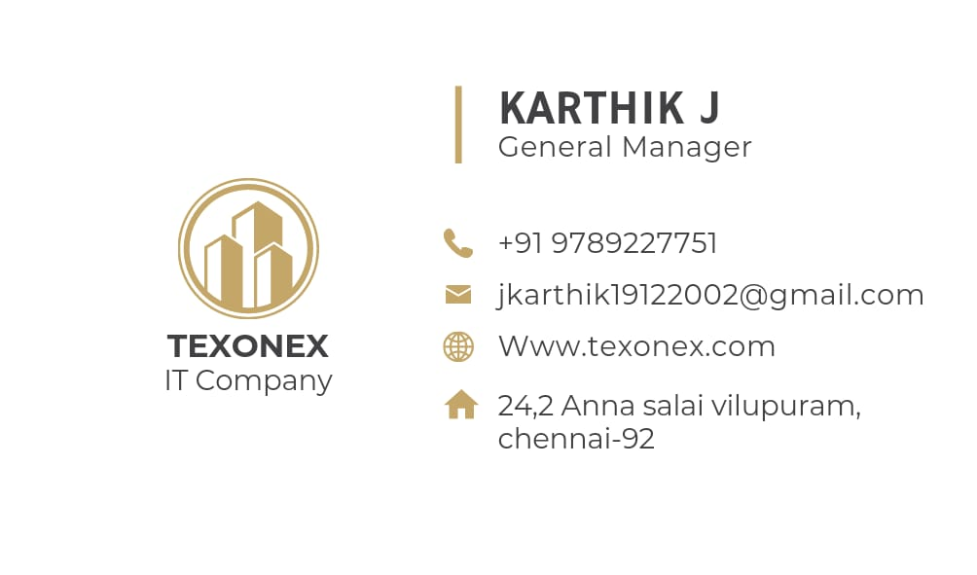

**TIE EVENT-NETWORKING**

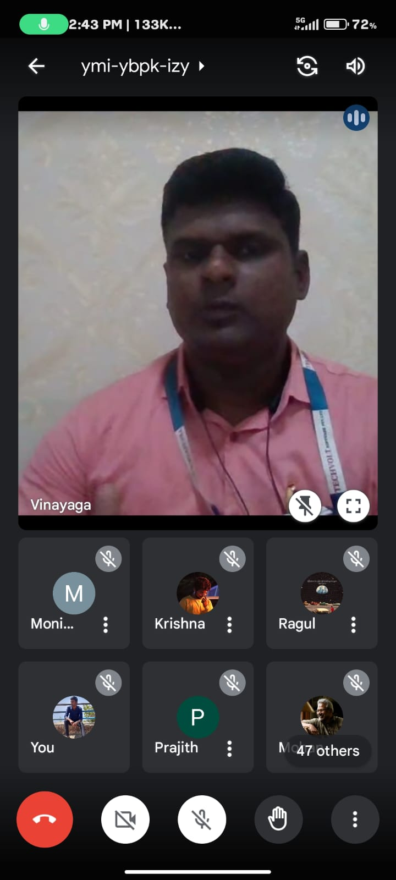

**ONLINE IMAGE AND BRANDING**

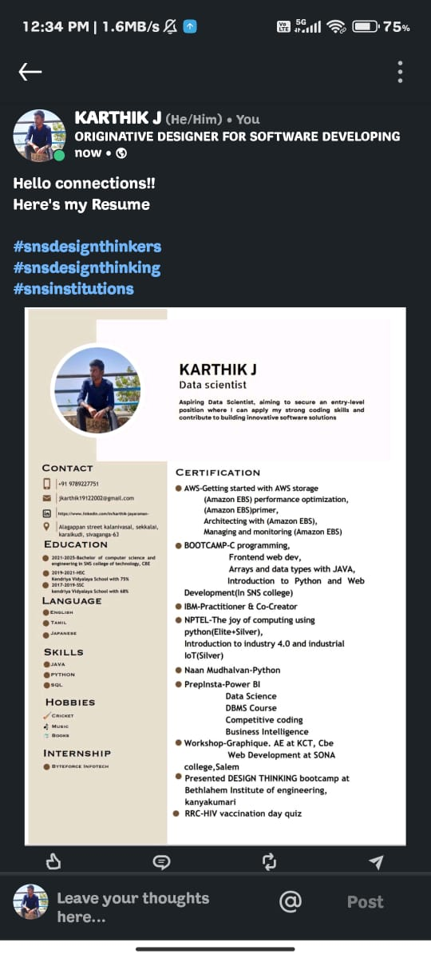

**EXERCISE IN CAREER PORTALS**

